<http://www.picone.co.uk/>

axles, motors, screws, worm gears places not too close to pcb (printed circuit board) else it will rub the encoders off.

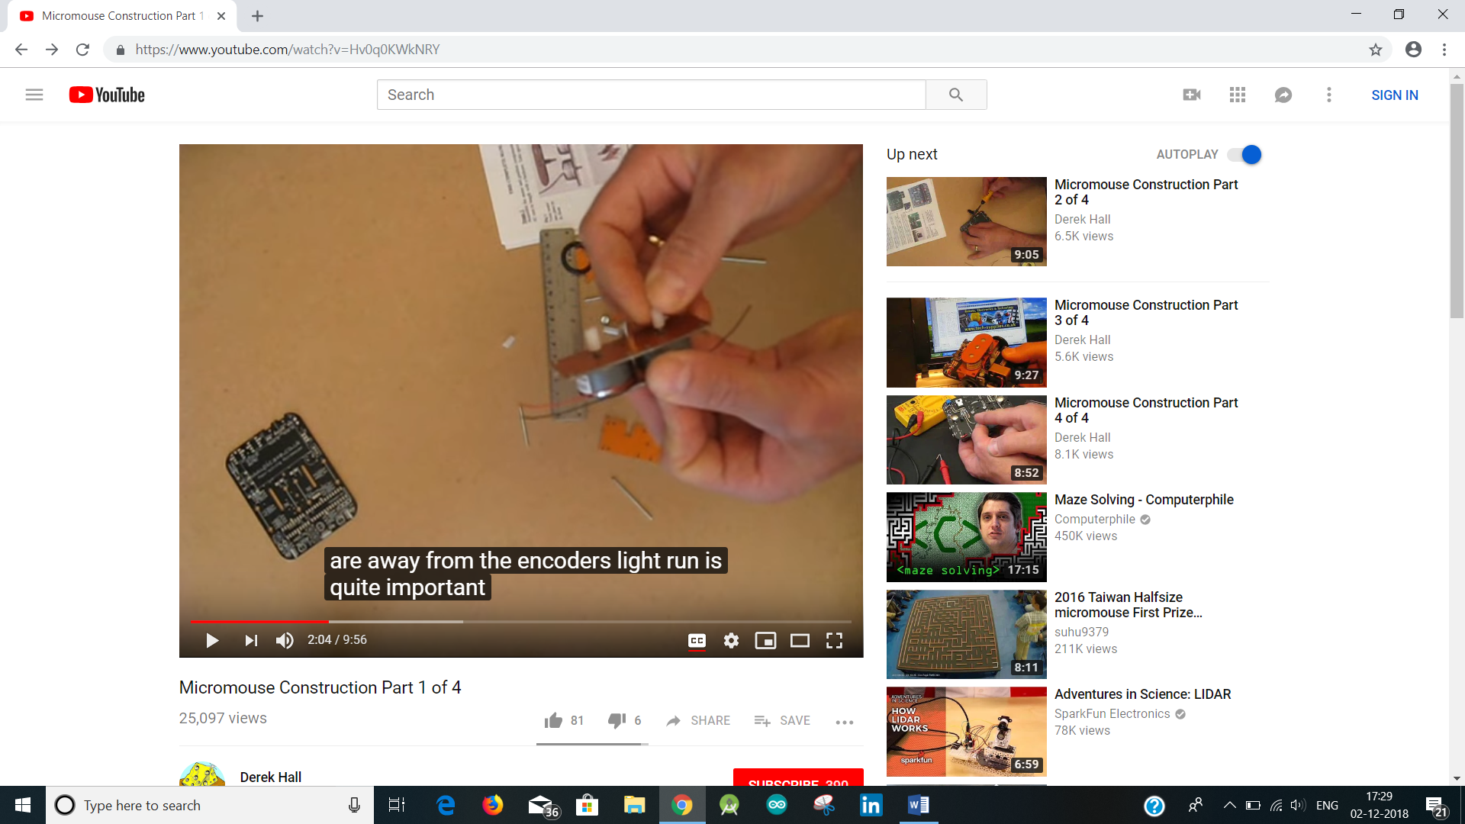

Worm gears are powerful, because if the mouse gets stuck against the wall, the worm gear keeps rolling but the wheel will start to slip on the axle

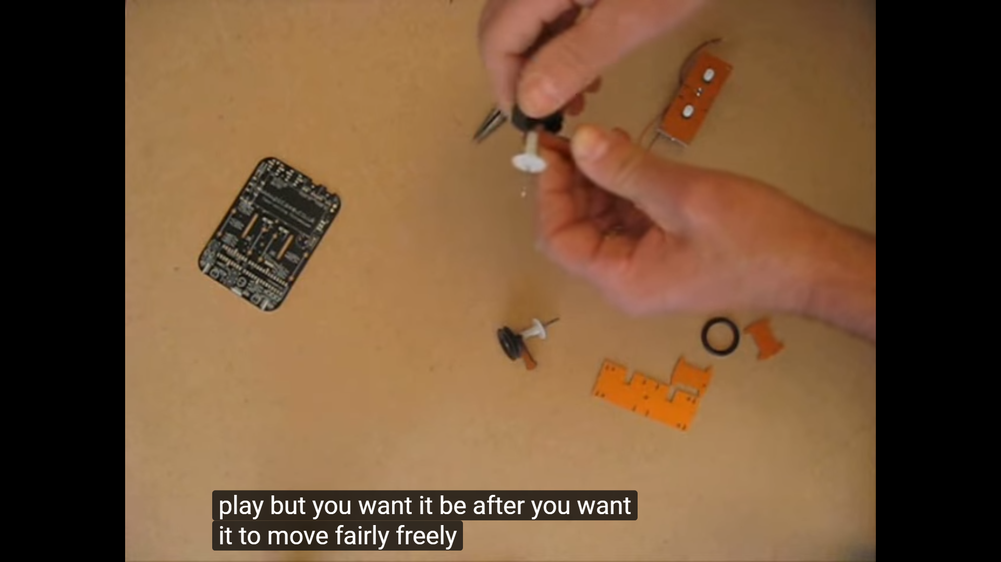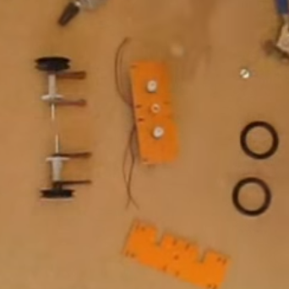

Make sure no glue on gear

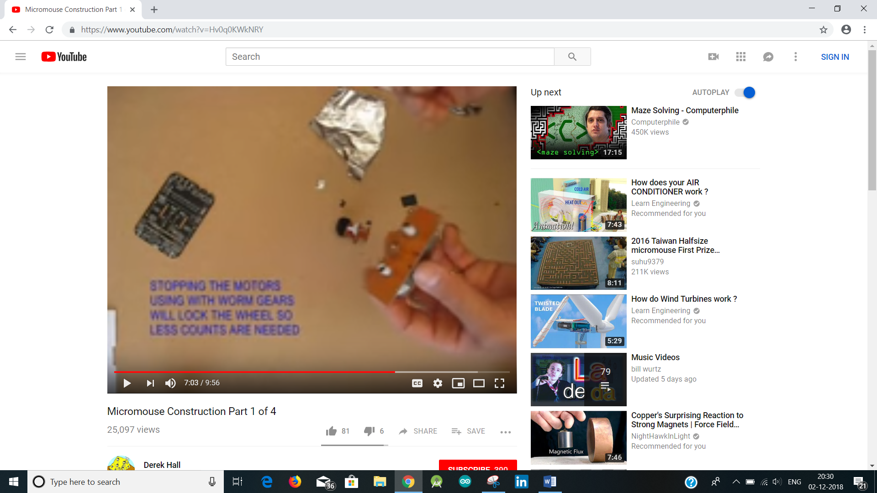 

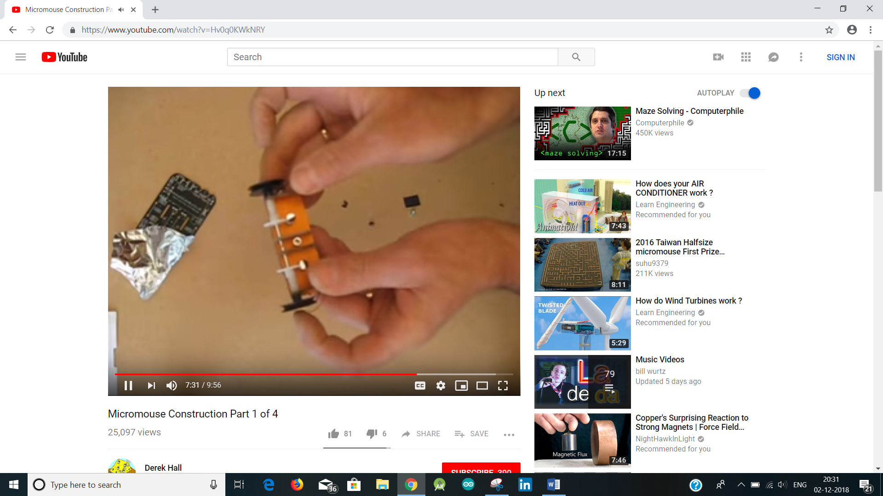 fix the motors with worm gear.

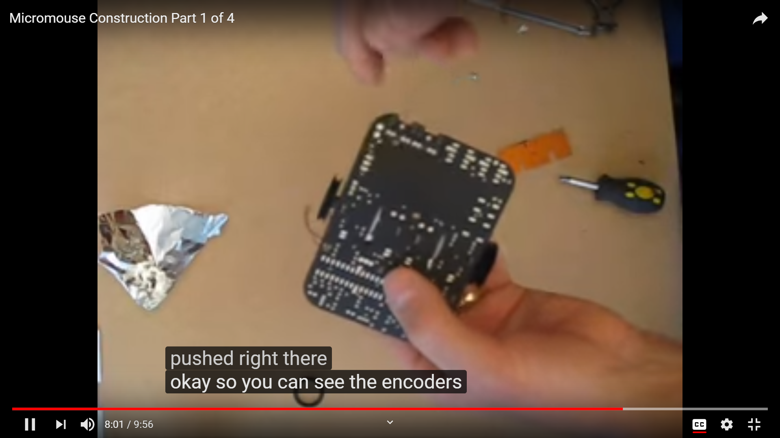 look at the wheels placed exactly and encoders???

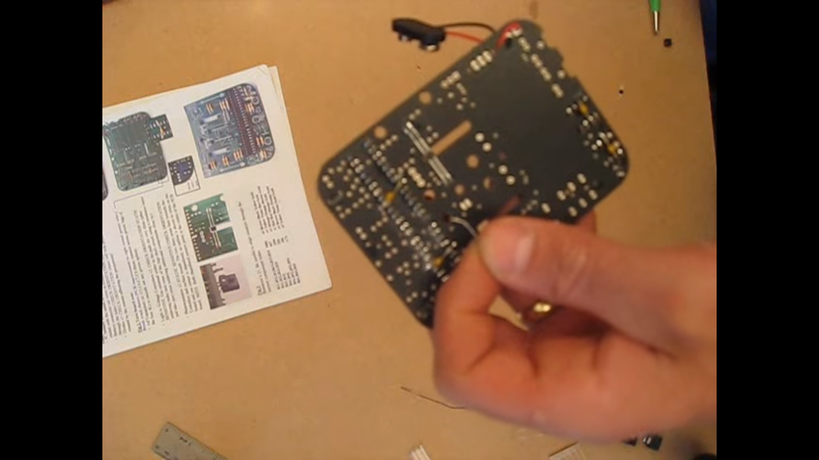

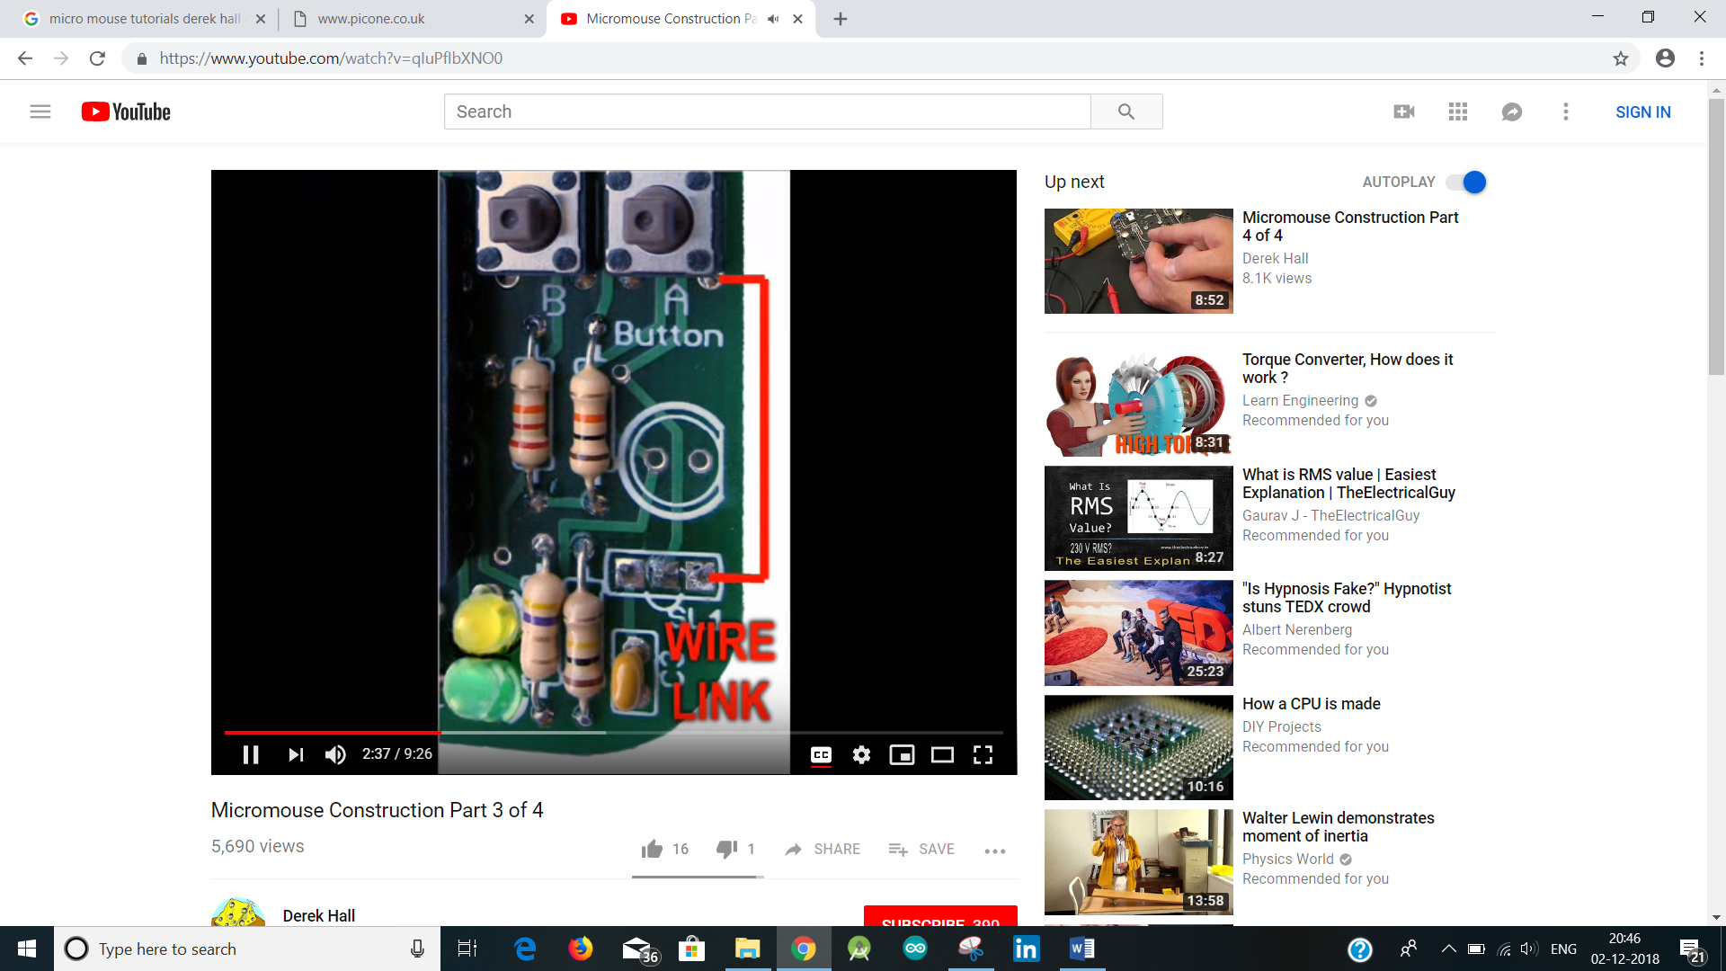

To increase the speed increase the power of the motors and speed of processor.

28 x 2 and 10MHz resonator processor. 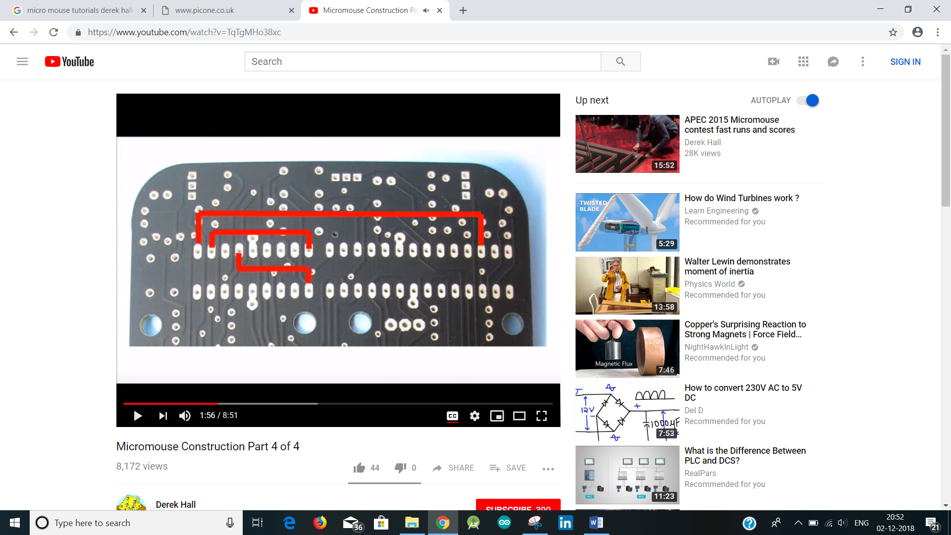

Processor connected with pins to resistor and push buttons

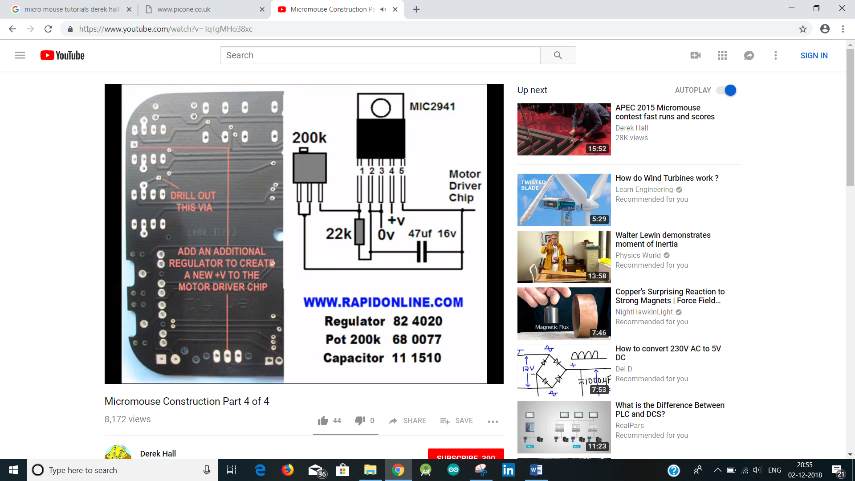

Variable regulator to motor driver chips

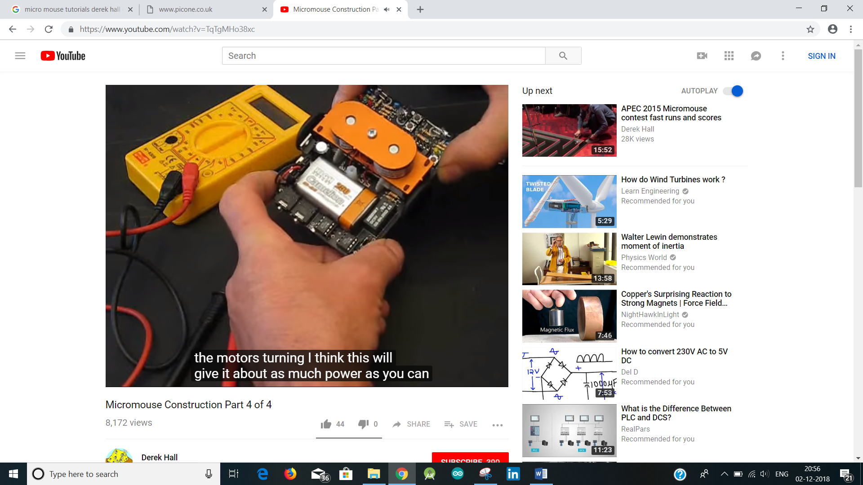

High capacity 9V battery. 